Project proposal

GUNS KILL,

Analysis of the American Gun Crimes



Charlene Moore

Data Analytics

[x15412048@student.ncirl.ie](mailto:x15412048@student.ncirl.ie)

BSc (Hons) in Technology Management

2018/2019

## Objectives

Statistically analyze a large data set, made up of smaller data set integrated into the one. The data sets must all support the topic I have chosen for my project, Gun Crimes in America.

## Background

My reason for choosing my topic to be Gun Crimes in America is partly because of the shooting in Las Vegas last October 1st. I happened to be on the strip the time of the shooting and have since been really interested to know more on the Gun Crime laws and death rates.

The fact that the perpetrator legally owned approximately 50 guns, varying capacities, resulting in the deaths of 58 people and injuring hundreds. It makes me very interested to know more on the topic; if larger states like California who have a more restricted approach to gun laws have a lower crime rate? Or if it has any effect on the gun crime rate at all in comparison to states that aren’t as restricted?

## Technical approach

After I have researched my topic and find my datasets on Gun Crimes, I will integrate and cleanse them until I am left with only data that is relevant to my project. Once I have a deep understanding of my dataset, I will then move on to my analysis.

I will use a combination of tools and techniques to determine trends, links, patterns, and make predictions between variables.

I aim to cleanse all my data using excel and RStudio. I hope to complete most of my project on RStudio as I am using this software in one of my modules and hope to become very used to the tools it offers.

I will be using Tableau to do most of my visuals. I hope to have many types of visuals such as Histograms, Scatter Plots, Pie Charts, Geographical Charts etc.,

I wish to eventually towards the end of the project, make predictions in my dataset using machine learning algorithms. Some examples of machine learning algorithms would be Random Forest and K-Nerest Neighbour.

I will also try to make use of SPSS and R Shiny too.

I will be backing up my project throughout, using GitHub.

To demonstrate my project in the Final Presentation, I will present it on a Project Website, constructed using a software like WordPress.

## Special resources required

To complete my project, I will be using the following resources:

* Kaggle and Data.Gov– For Public datasets on Gun Crimes
* RStudio
* Tableau
* GitHub
* SPSS
* Book: `Statistics for people who (*think they*) hate Statistics`
* Book: `R Cookbook`

I may pick up a few resources along the way. I am open to new technologies and new resources to help create a great project.

## Project Plan

Semester 1 CA plan to keep track of deliverable dates.

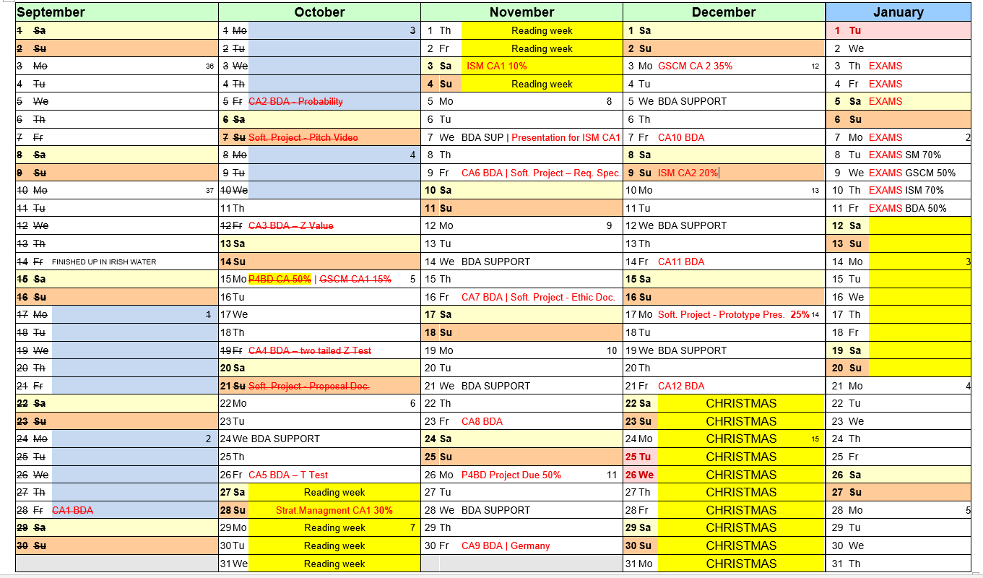

I have a Gantt chart made, I will input it later as my Citrix isn’t working right now, and I am on my laptop and don’t have M.S. Project on this unfortunately.

Regarding my Gantt, I have it very brief momentarily but have the main milestones and tasks included.

I need to narrow down and define the scope of my project. What is my focus? Is it focusing on gun rates with legalized weapons? Or is it gun rates in poverty areas, restricted law areas or what is the scope?

## Technical details

Language used is R.

Principal libraries? Is this R Shiny? Or GitHub? (Research more on this!)

## EVALUATION

My mid-point objectives are:

* Data Set picked, finalized and understood.
* Data set cleansed.
* Preliminary Analysis.
* Statistical tests planned and one or two conducted.
* Visuals-charts
* A bit of research, great understanding of the datasets and any potential links is vital.
* Add in a few geographical and regional visuals too.

I hope to achieve a great outcome in this module by inputting a massive amount of effort and attention.

I will evaluate more on my project at a later stage in the project. Currently I have not enough work done to reflect on. (19/10/2018).